FL Capstone — How I Will Add My Next Case Study
Name: Azan Shah
Track: General AI Fluency
Capstone: FL — Keep It Growing
Week: 6
1. How I Will Add My Next Case Study
I will add my next case study to the Projects/Work section of my portfolio, using the same structure as my existing case studies.
Each new case study will follow three simple beats:
1. Problem
I will explain:
- What problem or task I was working on.
- Why the problem mattered.
- Who the work was intended to help.
- What the starting situation was.
I will keep this section focused on the actual problem rather than giving unnecessary background.
2. What I Did
I will describe the important work I personally completed.
This will include:
- The approach I took.
- Tools and technologies I used.
- Important decisions I made.
- Problems I encountered and how I handled them.
- Where AI helped and where I made the final decisions myself.
I will use real screenshots, code examples, or other evidence where useful instead of making generic claims.

3. What Came of It
I will finish with the outcome of the work.
Where possible, I will include:
- Measured results.
- Improvements or observations.
- What I learned.
- Limitations of the result.
- What I would improve next.
I will avoid unsupported claims and clearly distinguish between measured results, observations, and future plans.

2. Steps I Will Follow
When I have a new project or meaningful piece of work, I will:
- Choose the work that adds something new to my portfolio.
- Collect evidence such as screenshots, results, GitHub commits, or demos.
- Write the Problem in a few clear paragraphs.
- Write What I Did, focusing on my decisions and contribution.
- Write What Came of It, using real results where available.
- Edit the case study to remove generic AI wording and unnecessary details.
- Add relevant screenshots that prove the work.
- Keep the same visual identity from my existing portfolio.
- Add the case study to the Projects/Work section.
- Check the live portfolio on desktop and mobile before considering it complete.

3. My Next Case Study
Next Piece of Work: FlyRank Machine Learning Internship — Content Opportunity / Baseline Action Scoring
My next case study will be based on my FlyRank Machine Learning internship work, particularly the work where I built a baseline action-scoring approach for identifying content opportunities.
The case study will focus on how I moved from raw content/search-performance data to a simple decision-support queue.
Problem
The case study will explain the challenge of identifying content pages that may deserve attention based on measurable search-performance signals.
What I Did
I will describe how I:
- Framed the problem as an ML/data problem.
- Defined the unit of analysis and data contract.
- Worked with search-performance data.
- Investigated signals such as impressions, CTR, and position.
- Built a baseline scoring rule.
- Assigned reason codes and actions.
- Reviewed the highest-ranked recommendations critically.
- Checked for leakage and avoided future or label-derived information.
What Came of It
I will document the actual measured results from the internship work, including the baseline's behavior and limitations.
I will also explain that the baseline is decision-support, not proof that changing a page will definitely improve its performance.

4. Where the Case Study Will Go
The case study will be added to my portfolio's Projects/Work section.
The structure will be:
Project title → Short summary → Problem → What I Did → What Came of It → Evidence → Technologies → GitHub/Demo
I will keep the page visually consistent with the existing portfolio rather than creating a completely different design for each project.

5. Reminder
I will set a reminder to add the case study after completing the relevant internship work.
Reminder
Title: Add FlyRank ML Case Study to Portfolio
Action:
Review the completed FlyRank work, collect evidence, write the three-beat case study, and publish it to the portfolio.
Frequency: One-time reminder after the relevant internship work is complete.
Evidence:
I will submit a screenshot of the calendar/reminder showing the reminder title and scheduled date.
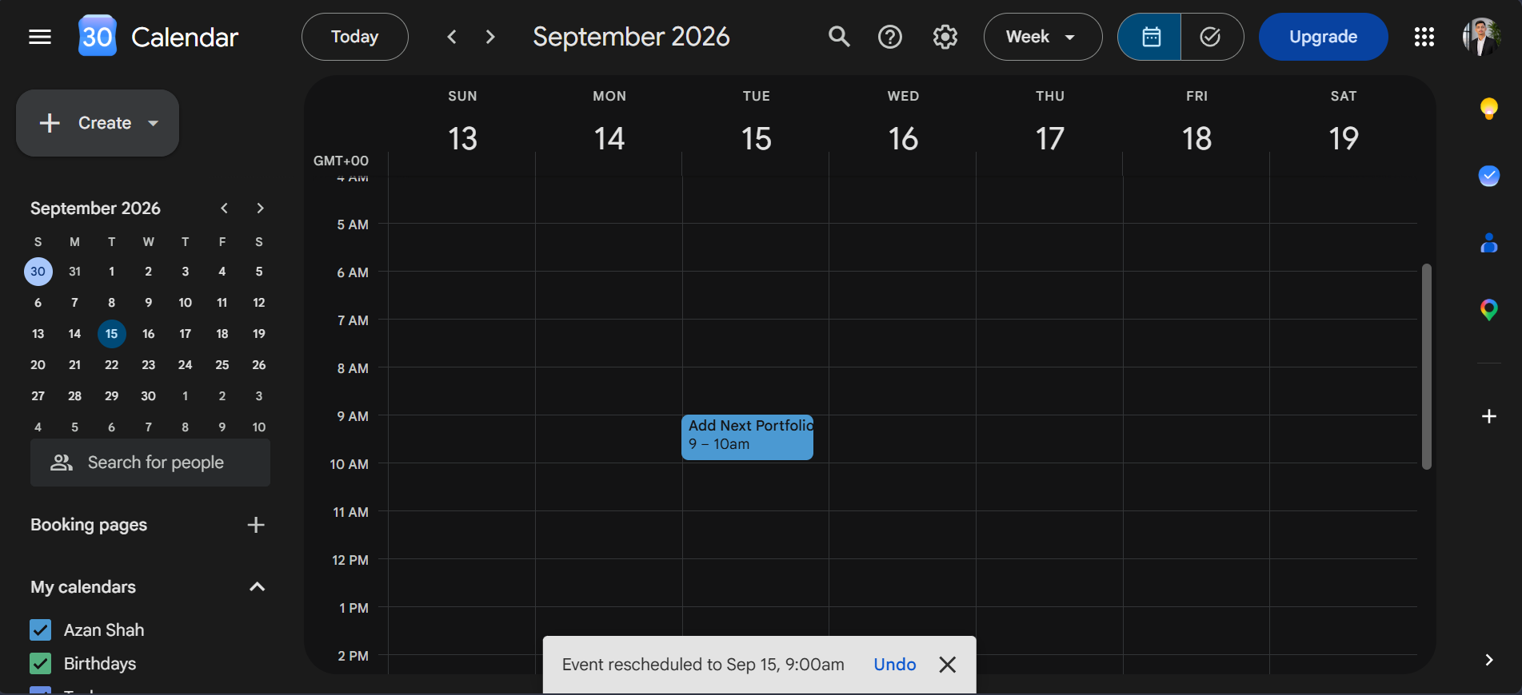
6. Keeping My Build Context
I will keep my Claude Project rather than starting from scratch for every future case study.
The project will retain:
- My preferred writing voice.
- My portfolio identity and visual direction.
- My technology stack.
- My case-study structure.
- My existing portfolio context.
- My identity kit and style decisions.
For the next case, I can therefore give the AI the new project evidence and have it help me interview, organize, and draft the case without rebuilding the portfolio context.
I will still review and edit the final writing myself so that the case study represents my actual work and decisions.

